**Correlational analysis**

In this study, the researcher sought to establish the relationship between age, gender and social distance. Analysis of the initial dataset was established as below;

**Correlation between age and social distance results**

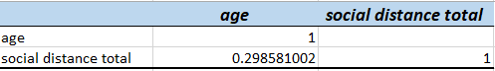

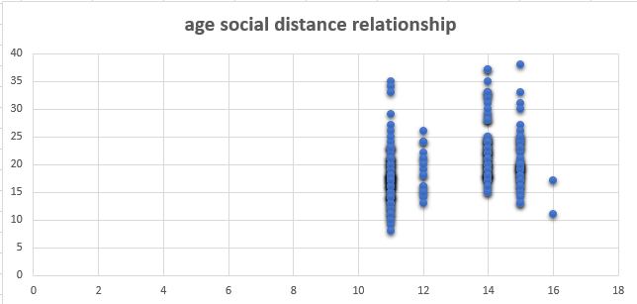

**Discussion:**

From the results of the analysis above, it can be seen that there is weak relationship between the age of a participant and their social distance. In this case, the independent variable selected as was social distance does seem to change significantly as the age of the participant increases. And the vice versa is true that social distance does not seem to change valiantly as the age reduces. The result is some kind of a scattered distribution, actually, if a line of best it is established on the graph, the linear regression determination becomes null since no pattern exist. Further, the correlation matrix produces a value of 0.29858 which is very low and far away from 1, which clearly indicates that the two variables do not depend on each other in any way. Age and social distance of the participant are not related.

**Gender and social distance**

The results from gender and social distance are summarised below based on the analysis done;

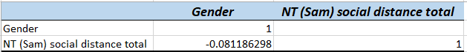

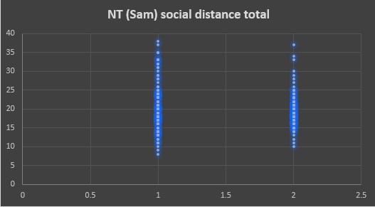

**Summary of the correlation model**

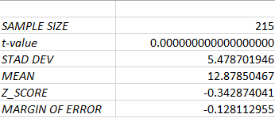

**Discussion**

From the graph obtained above between gender and the social distance of the participants, it can be seen that since we are measuring two variables that are almost Boolean in nature, the relationship is inferentially skewed, even though it can be most observed that chances of males dominating higher social distance is higher because they are the majority in the population. However, it terms of linear correlation, the two datasets are not related, in fact, the correlation coefficient value gives –0.081, which is weaker from 1; this can be interpreted to mean that there is no relationship between gender and social distance. I.e. if gender changes, this does not affect the social distance of the participant. Additionally, if we establish a line of best fit from the data, it establishes no uniform movement of the data or objective being established, so we can conclude that gender does not affect the social distance of the participant.

Further analysis done based on as a sample dataset distribution of 215 entities in the population compared age and the social distance between the participants. The relationship established relationship between values as follows;

T value of less than *0.0000.* Showing a greater difference from the objected null hypotheses earlier discussed in the chapter, this is just to highlight that the two variables against confirm greater none linear relation among each other.

The standard deviation output from this sample of 215 indicated that a value of 5.478 was established; if we extrapolate this against an inferential value of 1.0, this further establishes that that their data point relationship among these two are widely spread out and none, is a causative agent of the other. Further Z score value derived as -0.34 indicates a reflection further away from the mean score value derived from the same dataset. Inferentially from sample mean of 12.88, the margin of error scored at -0.12, what this means is that the margin of error boundary is lightly significant to the researcher, revealing a near to less correlation between the given two datasets, i.e. considering age and the social distance.